From: Major Jack Musgrove RA
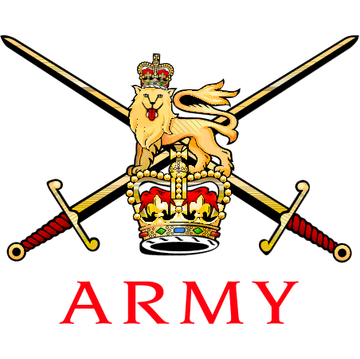 | Army Golf Captain  SO2 CFM Res, CM Ops  Army Personnel Centre  Kentigern House  65 Brown Street  Glasgow, G2 8EX
 | Mil/Skype:  Mobile: | 0300 1633647  07715 336186

Distribution: See below 18th Jun 2021

Dear Commanding Officers,

Army Golf – The Army vs The Civil Service – 2 Aug 21 – Royal Liverpool GC

- Selection. The following have been selected to represent the Army against the Civil Service:

Rank/Name | Capbadge | Unit | Remarks
Maj JR Musgrove | RA | APC Glasgow | Captain
Lt NC Williams | LANCS | ATC (P)
WO1 Sanby | AGC (SPS) | 101 Regt RA | Team Manager
SSgt Bradley | AGC (RMP) | 1 RMP
Cpl Over | RE | 24 Cdo Engr Regt | Vice-Captain
LCpl Blick | PARA | 2 PARA
Fus Phillips | RRF | 1 RRF
Gdsm Slater | COLDM GDS | RG Colchester
Fus Stevenson | SCOTS | 2 SCOTS
Spr Torrie | RE | 22 Engr Regt

- Availability. Commanding Officers (or Line Managers) are kindly requested to release their players to represent the Army in this fixture. If any player becomes unavailable, they are to inform the Army Golf Captain or Team Manager at the earliest opportunity.

- COVID-19. All participants should ensure they follow the current Direction & Guidance in accordance with the Force Health Protection Instruction, ASCB and Government advice at all times; this includes receiving the Force Health Protection Brief and the AGA Practical Guide. Participants should stay with their playing group and should not congregate in any more than groups of 6 in and around the club facilities.

- CO/Line Manager Authority. Prior to completing your entry into this event, you are to ensure that this AI is brought to the attention of your Commanding Officer (CO) or Line Manager for approval. A copy of the AGA and Venue Covid-19 Risk Assessment and the Actions on Contamination (which you should read) are enclosed and CO’s are to satisfy themselves they are content for the SP to be released. Should your availability for this match change, please contact the undersigned at the earliest opportunity.

- Reporting. Players are to report the Captain in the Royal Liverpool Clubhouse at 0815hrs. The first morning tee time is at 0904hrs.

- Format. 5 x foursomes (morning) and 10 x singles (afternoon) scratch matches. Lunch will be provided between rounds.

- Accommodation. The Army Golf Association has booked all players accommodation at the Holiday Inn Express in Hoylake for the evening of 1 Aug 21 (Postcode CH47 1HE). The Team Manager is to coordinate check-in and room allocation. Breakfast on the morning of 2 Aug 21 is included.

- Equipment and Dress. Players are to wear PING red Army shirts/mid layers as issued and black trousers. Individuals without an Army Top are to inform the Team Manager ASAP. Jacket and Tie is not required for this fixture.

- RAPS. Reserve SPs are to ensure that this letter is forwarded to their XO or RTO. It is the SPs Parent Unit’s responsibility to create a CHURCHILL Event or award STs for the duration of this fixture.

- Travel Authority. The use of the Representational Sport Travel Vote is authorised for this fixture in accordance with 2019DIN10-025. Applicants are to use their own UIN and Purpose of Travel (POT) Code 16 and also quote their own or the bidders unit UIN on the FMT 1000 when applying for white fleet vehicles. Players should make every effort to minimise costs by vehicle sharing,, however private car sharing is still prohibited.

- Drivers Hours. It is each players responsibility to comply with Drivers’ Hours Scheme A, details of which can be found in DSA 03. Movement and Transport Safety Regulations. Given that this fixture will be played over 36 holes, the daily duty time on 2 Aug 21 will exceed 9 hours prior to dispersal. Plans for return travel should be considered accordingly. Players can seek further guidance on this matter via their unit MT Reps or the Army Golf Team Manager. Any player requiring local accommodation on the evening of 2 Aug 21 to satisfy drivers’ hours must inform the Captain as soon as possible. Any player found to fail to occupy this accommodation have the accommodation charges recovered from them.

- On Duty Status. Players should advise their Unit HR Reps to ensure that their participation is published on respective Unit Part 1 Orders to formalise their ‘on duty’ status for this event.

- Summary. Due to the pandemic, this is the first Army Golf Team fixture in over 22 months. This match is an important part of the Army’s preparation for the Inter Services Championship in September. It is also an excellent opportunity for our golfers to compete at Royal Liverpool Golf Club, which will host the 151st Open Championship in 2023 and is one of the most prestigious venues in golf.

Yours sincerely,

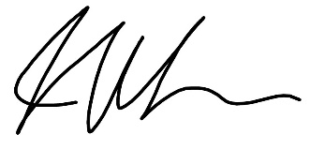

Jack Musgrove
Major
Army Golf Captain

Distribution:

CO/LMS fo Selected Players*
All Selected layers*
Brig Pullan (Army Golf Chairman)
Lt Col (Retd) Davis (AGA Sec)
Miss Walters (AGA Ass Sec)
Enclosures:

1. AGA RA
2. Venue RA
3. COVID Actions On Contamination

