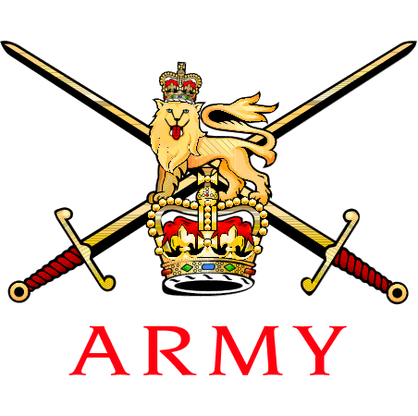 | Capt IJ Wells  Quartermaster (Technical)  R SIGS Corps golf secretary  30th Signal Regiment  Gamecock Barracks  NUNEATON  Warwickshire  CV11 6QN  Telephone: 03001 690309  Email: Ian.wells648@mod.gov.uk

Secretary golf and Winter sports | Reference: | RSIG/Corpsgolf/21-06A
 | Date: | 23 July 2021

R SIGNALS INTRA CORPS GOLF AT HAYLING GOLF CLUB ON 28 JULY 2021 - ADMIN INSTRUCTION

References:
A. JSP 660 – Sport in the UK Armed Forces
B. JSP 752 – Tri Service Regulations for Expenses and Allowances
C. JSP 800 – Defence Movement and Transportation Regulations
D. 2019DIN10-025 (June 19) – Travel at Public Expense for Army Sport
E. AGAI Vol 1 Chap 5 – Sport
F. https://www.haylinggolf.co.uk

- General. In place of the scheduled Corps match against the Royal Artillery, the R SIGNALS will play an intra Corps match at Hayling Golf Club, Links Lane, Hampshire, PO11 0BX on 28 Jul 21. Team players are named in table 1 below. SSgt Paul Dickinson is the nominated overall Captain for the day.

SELECTED
Ser | Rank | Surname | Handicap | Personal cost | Team
1 | Lt Col | Boyle | 8.8 | £50 | Albatross
2 | Major | Nowosielski | 3.5 | £45 | Eagle
3 | Capt | Tek | 7.1 | £45 | Eagle
4 | Capt | Wells | 12.8 | £45 | Eagle
5 | WO2 | Prem | 8.4 | £40 | Albatross
6 | SSgt | Dickinson (C) | 2.2 | £35 | Albatross (C)
7 | SSgt | Thrower | 6.1 | £35 | Eagle
8 | Sgt | Hodge | 16 | £35 | Albatross
9 | Sgt | Milan | 2.5 | £35 | Eagle (C)
10 | Sgt | Milton | 23.5 | £35 | Eagle
11 | Cpl | Dawson | 2.9 | £30 | Albatross
12 | Cpl | Loft | 16.7 | £30 | Eagle
13 | Sig | Mustchin | 16.8 | £30 | Albatross
14 | Mr | Fisher MBE | 13.9 | £45 | Eagle
15 | Mr | Hatcher | 12.1 | £45 | Albatross
16 | Mr | White | 17.8 | £45 | Albatross
Table 1

- Competition play. The format for the competition is as follows:

  - 4 ball better ball. The AM round will be played as four 4BBB matches.

  - Individual. The PM round will be eight individual matches.

- Timings. The outline for the day is as follows:

  - 0800hrs – Arrival of both teams; social distancing measures are to be adhered to and strict CV-19 rules are to be obeyed. Bacon sandwiches and coffee will be served by members of the GC staff to the table. Each team is to sit as a Corps on two separate tables of four, there is to be minimal movement around the bar area. The Captains will then discuss pairings outside.

  - 0900hrs – First morning tee.

  - 1300hrs – Rolling lunch (sandwiches) will be served to tables. It is to be eaten in the four balls which you have played in, there is to be minimal movement around the restaurant.

  - 1400hrs – First afternoon tee.

  - 1830hrs – Dinner, again, you are to dine with the fourball that you played golf with for the duration of the day and there is to be minimal movement around the GC. Speeches to follow.

- Refreshments. The cost for the day includes bacon sandwiches on arrival, soup and sandwich at lunchtime and a light supper. All other refreshments will be at a personal cost.

- Cost. The cost is heavily offset by the Corps golf fund and is rank ranged as follows:

a. Lt Col: £50
b. Major / Capt / Retired soldiers: £45
c. WO2: £40
d. SSgt: £35
e. Cpl and below: £30

6. All payments are to be made to the Corps Captain of the day, ideally by bank transfer, who will subsequently transfer the monies to the relevant regimental bank account. Separate invoices have been generated by the GC.

7. Transport. This fixture has been added as an official Corps Representative fixture and is also published on the ASCB Fixtures List. Details for Travel for Army Sports can be found at Ref D. Travel should be charged to the UTB within affordability. Under no circumstances are participants to car share in private vehicles. If you are unable to comply with MOD driving hour regulations, you should consider playing this event.

8. Club House Dress. Smart casual wear is acceptable throughout the competition, no jeans or collarless shirts, Corps shirts are expected to be worn. Golf shoes are not to be worn in the clubhouse. Jacket and tie is not required for dinner – no towels are provided at the GC.

9. Competition Rules. No cards will be handed out on the day, the match play event scoring is straightforward.

10. On Duty Status. Players should advise their RAO to ensure that their participation in this event has been published on respective Unit Part 1 Orders, to formalise their ‘on duty’ status for this event.

Safety

11. All participants are to comply with HMG direction on maintaining 2m social distancing at all times. Due to COVID-19 players must meet certain policy in order for the event to be played in line with the Army Golf Association Guidance. This can be found at the link AGA Practical Guide for Event Organisers . All attendees must watch- https://jive.defencegateway.mod.uk/videos/16686 and then log in to Defence Connect to complete the self-declaration form 24hrs prior to the event. Declaration can be found here; https://www.armygolf.co.uk/fhpbrief2020/. Participants should also familiarise themselves with FHGC’s own COVID-19 safety measures and specific rules in place. The Corps secretary for the R SIGNALS (Capt Ian Wells) will forward a complete nominal roll of attendees NLT 24 hours before the match commences and again straight after the match confirming attendance to the AGA secretary.

CO / Line Manager Authority.

12. Prior to completing your entry into this event, you are to ensure that this AI is brought to the attention of your Commanding Officer or line manager for approval. A copy of the Covid-19 Risk Assessment from the GC is attached to the email and the Actions on Contamination (which you should read) are enclosed at Annex A. CO’s are to satisfy themselves they are content for the SP to be released. Should your availability for this competition change, please contact the undersigned at the earliest opportunity.

Captains Responsibilities

13. As the nominated captain of the day SSgt Paul Dickinson you are to ensure that you complete the following responsibilities:

a. Pre-fixture responsibilities
b. Match day responsibilities
c. Post-match responsibilities

14. Pre-fixture Responsibilities. Inform the secretary by 26 Jul that all golfers listed in Table 1 have confirmed that they are available for the match.

15. If you have not heard from a player confirming their availability, you should make every effort to call them. Please use your own judgement before calling the reserve forward. There is to be no social media plea for players. Once you have established the final team you must email the Corps Secretary and give him the names.

16. It is imperative that there are 16 players present at Hayling Island GC to represent the Corps.

17. Match Day Responsibilities. Table 2 contains your match day responsibilities

Ser | Task | Check
1 | Ensure 16 players are present
2 | Pick team and brief team on the pairings for the day
3 | Introduce yourself to the captain of the day
4 | Confirm format (morning – 4BBB, afternoon singles matchplay in 4B’s same pairings)
5 | Hand pairings to opposition captain
6 | Discuss dress policy and feeding arrangements with opposition captain
7 | Gather team together, take a team photograph – white Polo shirts on display (either indoors or outside)
8 | Encourage other photos to be taken (without breaking etiquette)
9 | Encourage players to use Twitter to update score and match results for all to see
10 | Book fixture for same time following year
11 | Collect money (NO cheques are permitted – remind all players)
12 | Collate scores and complete the results sheet (Annex A)
13 | Gather information from the pairings for the post-match report
14 | Sing for your supper – thank you to the opposition, club Staff etc and a quick summary of the match (no negative comments) including the result.
Table 2

18. Post-match responsibilities. Table 3 contains your post-match day responsibilities; ensure you check each task.

Ser | Task | Check
1 | Complete the results sheet electronically
2 | Complete the attached post-match report sheet (Annex B)
3 | Send result sheet, post-match report and team photographs (and any others) to the Corps Sec within 5 days of the match
4 | Send money to RBS account (Central Bank 30 Sig Regt) within 5 days of the match  Sort Code: 161926 Bank account Number: 10615194  Use reference – GOLFRA
Table 3

19. You must remind all golfers that they are representing the Corps, their Unit, the team and themselves. The game relies on their integrity, consideration for their opposition, care for course and that they abide by the Rules of Golf. All players must conduct themselves in a disciplined manner, demonstrating courtesy and sportsmanship at all times.

AVOID SLOW PLAY – BE PATIENT – ENJOY YOUR GOLF – PLAY WELL

(Original signed)

IJ Wells
Corps golf secretary
Ian.Wells648@mod.gov.uk

Annexes:

- Immediate Actions on CV19

Copied to:

All R Sigs players*
R Sigs Corps golf chairman*

Annex A to
RSIG/Corpsgolf/21-06
Dated 12 Jul 21

Immediate actions on CV-19 contamination

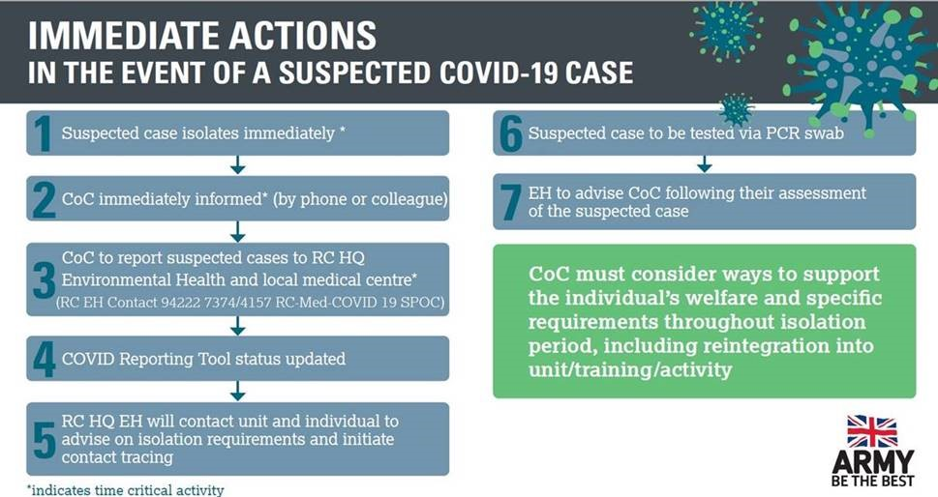

Handicaps may have changed since these figures have been submitted

