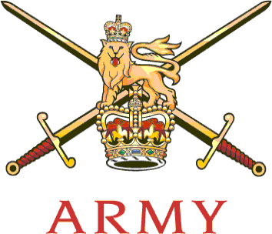 | SO1 Service Complaints  Army Personnel Centre  Mail Point 502  Kentigern House  65 Brown Street  GLASGOW G2 8EX  Telephone: 0300 153 9844  Facsimile: 0141 224 3018  Email: stuart.campbell201@mod.gov.uk | 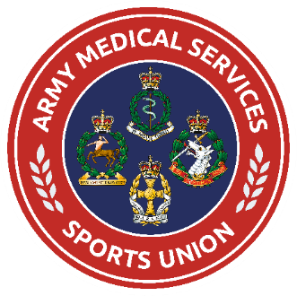

See Distr | Our reference: AMSG/AMS v R SIGNALS 21  Date: 29 June 2021

AMS V R SIGNALS MATCH – 14 JULY 2021
ADMIN INSTRUCTION

1. Introduction. The annual match against the Royal Signals will take place at Basingstoke GC on 14 July 21. Each team will comprise of 8 players. The match will be run in compliance with the ABN 095/2020 as well as the Basingstoke Golf Club Risk Assessment and the AMSG Risk Assessment, which are enclosed. It is essential that you read all 3 documents. You are also all required to complete the AGA online self-declaration form on their website here AT LEAST 24 hours prior to the start of your event. The match is subject to approval by the ASCB.

- Compliance. This event will take place in accordance with ABN 036 2021, the SGC Risk Assessment, AGA Risk Assessment and the COVID-19 Actions on Contamination. Players are advised to read all these documents (available on the AGA website) and Commanding Officers are to be made aware prior to the release of participants.

- CO/LM Authority. Prior to completing your entry into this event, you are to ensure that this letter is brought to the attention of your Commanding Officer (CO) or Line Manager (LM) for approval. A copy of the COVID-19 Risk Assessment and the Actions on Contamination are enclosed above, and COs are to satisfy themselves that they are content for the SP to be released. Should your availability for this event change, please contact the AGA at your earliest opportunity.

- Format. Matches will be played in 4-balls. The morning format is 4-Ball Better Ball and the afternoon will be singles matches playing in the same 4-Balls as the morning event. Each team will try and match HCaps. All players are to be members of the AGA; AMS players must also subscribe to the Day’s Pay Giving Scheme.

5. AMS Team. The following have been selected to represent the AMS:

- Maj Johnson – 256 Fd Hosp (Team Captain)
- Maj Cameron – MOD Abbey Wood
- Maj Marshall – 202 Fd Hosp.
- Maj Reynolds – 1 Armd Med Regt
- Capt Seal – PJHQ
- WO1 Mason – 22 Fd Hosp
- CSgt Rogers – 202 Hosp
- Cpl Evans – DMS(W)
- Sgt Wheeler – AMS Band

6. Timings. The main timings for 21 July are:

- 0700 - Arrive Basingstoke GC. Coffee + Bacon Rolls
- 0800 - AM 1st tee time
- 1200 - Rolling lunch
- 1300 - PM 1st tee time
- 1700 - Light snack + Depart as necessary

7. Travel. Travel for this match is authorised at public expense in accordance with 2019DIN10-025.docx (sharepoint.com). For costs claimed via unit imprest accounts, RAO’s must use their own UIN but quote Local Project Code (LPC) ZZP 1E1 1403 and resource Account Code PDA002. For contract travel bookings movement staff must use the appropriate UIN with Purpose of Travel Code (POT Code) 16, charged Resource Account Code PDA002. The appropriate Programme Travel GPC may also be used. Every effort must be made to minimise public travel costs and sharing of vehicles can only be by those in the same family bubble. You are to comply with advice given DAN19. A copy of this letter should accompany travel applications or claims. Private car sharing is still prohibited.

8. Cost. The match cost will be offset by AMSSU funds. Each player is required to pay £25 by bank transfer.

- Account name: AMSGS
- Acct Number 11244009
- Sort Code 16-19-26
- An individual ref (e.g. name) so that I can identify who has made payment

9. On Duty Status. Players should ensure that their participation in the event has been published on respective Unit Part 1 Orders, to formalise their ‘on duty’ status for this event.

10. Equipment Players are to bring all their own golf equipment for the event. Trolleys can be hired at Basingstoke if needed.

11. Dress. Players are to wear an AMS Golf polo top. White and/or navy shorts/trousers if they have them is preferred, but not essential. If any player does not have an AMS Gold polo they are to contact the undersigned separately.

12. COVID. Covid-19 still presents a risk and all players are to comply with the safety instructions given, If any player believes they have any symptoms they should not attend.

Original signed on MOD^{NET}

SW Campbell
Lt Col
Chairman AMS Golf

Distr: (by email)

All CO/LMs of Selected Players*
All players listed para 3*
Comd SM AMS – Sec AMSSU

