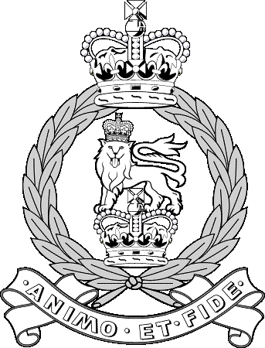
Assistant Secretary
Adjutant General’s Corps Golf Society
OTS(L) PATW
Defence College of Logistics, Policing and Administration
Building 101, Worthy Down
WINCHESTER
Hants, SO22 6LX

Email: Matthew.Priston241@Mod.Gov.uk
Telephone: 07590 633255

See Distribution Reference: RA GS Vs AGC GS

Date: 25 Aug 20

REPRESENTATIVE SPORT: AGC GS Vs RA GS– WED 2 SEP 2020

- Introduction. The AGC will play the RA at Hayling Golf Club on Wednesday 2 September 2020.

- Team Selection. The following have been selected to represent the AGC GS against RA GS at Hayling Golf Club on the above date:

Ser | Number | Rank | Surname | Handicap | Contact Number | Unit | Remarks
(a) | (b) | (c) | (d) | (e) | (f) | (g) | (h)
1 | 25132766 | SSgt | Priston M | 18 | 07590 633255 | PATW | Captain
2 | 25110902 | WO2 | Wilkinson G | 14 | 07584 674645 | 27 Regt RLC
3 | 25069647 | SSgt | Bird A | 11 | 01980 673611 | RMP PSD
4 | 25152737 | Sgt | Butler C | 13 | 01980 673715 | 4 Inv Coy SIB
5 | 25113359 | Capt | Avis S | 15 | 01980 844509 | RTR
6 | 30156551 | LCpl | Williams L | 15 | 01980 844541 | RTR
7 | 25218954 | Sgt | Whitehead I | 16 | 01980 651115 | KRH
8 | 24952141 | WO1 | Harwood W | 18 | 01264 383557 | Fd Army Pers Disc
Res | 25178478 | SSgt | Crate A | 17 | 07566235076 | RAFP GPW, Cranwell
Res

- Availability. All players listed above are to ensure that this letter is brought to the attention of your Commanding Officer (CO) or Line Manager for approval and confirmation that they are satisfied with the risk in participating in the event is ALARP. A copy of the COVID-19 Risk Assessment produced by the event organiser (Sec RAGA) and the COVID Actions on Contamination (which you should read) are enclosed and CO’s are to satisfy themselves they are content for their SP to be released. Should availability for this match change, please contact the undersigned at the earliest opportunity.

- Players are to assemble in the clubhouse at 0800, the first pairing will tee-off at 0845. The format for the day will be four ball better ball match play in the morning followed by lunch. The afternoon will be singles match play in 4 balls.

- Attire. Only formal golf attire is permitted and players are to wear their AGC Polo shirt. Players who do not have one are requested to wear a red polo shirt if possible. Jacket and tie are not required for after the match.

- Timings. As follows:

  - 0800hrs – Arrival
  - 0845hrs – Round 1 – 18 Holes Four Ball Better Ball
  - 1230hrs – Rolling Light lunch
  - 1330hrs – Round 2 – 18 Holes Singles (played in 4 balls)
  - 1800hrs - Depart

- Cost. The cost is £34 per head with the remainder offset by the AGC GS. All payments are to be made online, payable to the AGC Golf Society account:

- Account Number: 00405729
- Sort Code: 30-90-28
- Ref: AGCvRA/Surname

- Maj Amos is requested to send an electronic payment for £784 to Hayling GC as previously requested by WO2 Moore (email dated 31 Jul 20).

- Travel. The use of the Representational Sport Travel Vote is authorised. All players are to ensure costs are the minimum necessary to meet the requirement. MOD Travel rules in accordance with DAN-19 are to be followed. There is to be no private car sharing to this event.

- On Duty Status. Players are to ensure their participation is published on respective Unit Part 1 Orders in order to formalise their ‘on duty’ status for this event.

- Risk Assessment. The risk assessment has been completed by the RA GS, a copy of which can be found attached to this instruction.

- Match Report. The team captain is to ensure that a match report is e-mailed to the Corps Golf Secretary within 1 week of the match.

- Accommodation. No accommodation will be required for this event.

(Electronically Signed)

ML Priston
SSgt
AGC GS Asst Sec

Enclosures:

1. Event COVID-19 RA.
2, Action on Contamination.

Distribution:

Action

COs/ Line Managers of all players selected at Para 2.
All Players listed at Para 2.

Information:

AGC GS Chairman
AGC GS Treasurer
AGC GS Secretary

